**Focus Measurement for the Fore-optics of CHAI**

1. **The optics**

The fore-optics of the CHAI receiver is used to converge the output beam of the SIS mixer and match the receiver beam to the required telescope illumination angular range. Since the pixel spacing is 10mm which is fixed by the mixer Mechanical design, the modification of the mixer beam changes the ratio of pixel spacing () and the reciver beam waist () that is related to the ratio of telescope beam spacing () on the sky to the beam angular size ().

Figure 1.3D model and Gaussian beam propagation of the Fore-optics of CHAI.

The fore-optics uses the Cassegrain layout (**Fig.1**), one ellipsoid reflector and a hyperboloid mirror, to individually convert 0.916mm beam waist of the mixer to 3.333mm for each pixel at 475GHz. If assuming the illumination edge taper is around 18dB**,**  and ,are respectively:

The schematic of the optics is shown in Fig. 2.

5

21.21

11.052

8.696

Figure 2.Schematic of the Fore-optics.

The uncertainty of the position of the beam waist of the mixer horn causes significant changes in the beam waist position of the optics, which may affect the telescope focusing and reduce the efficiency. Therefore, the beam waist position of the mixer horn must be measured experimentally.

1. **Method and 1:3 Scale-up Model.**

We scale up the fore-optics and mixer horn, making them three times larger than the original model, because the large model can provide a larger margin for tolerating the measurement errors. The operating wavelength is also scaled up to 1.89mm (158.333GHz). Fig. 3 is the optics of the scale model.

Figure 3.1:3 scale-up model.

The position of the input beam waist can be derived from the best focus for a source located close to the optics. Fig. 4 illustrates the relationship between the beam peak power and the feedhorn position offsets, also depicts the variations of the best focus point with respect to different source-detector separations.

The best focus point for a given source-detector distance can be found by tuning the feedhorn position along the optical axis, until the maximum power is measured. The optimal mounting position of the horn for the CHAI receiver can be calculated numerically.

Figure 4.Best focus positions for the source at distances of 0.5, 0.75, 1.5, 2.5 and 1000 meters.

* **Parabolic and trigonometric approximations**

Directly and precisely measuring the best focus point is virtually unattainable. With the horn offset of 0.5mm from the optimal position, the power of beam peak undergoes a mere 0.15% (-60dB) change. But we can model the power changes with respect to the feedhorn offsets and use advanced fitting algorithms to fit the best focus point. Therefore, we first should build a proper model for the system. The analytic expression is a bit complicated, and it is also not obvious to show the maximum point. Two approximate expressions, parabolic and trigonometric approximations, will be used for the fitting process.

The curve shown in Fig. 4 exhibits a relationship that resembles a parabola. According to the Taylor expansion, the second order polynomials can express the values of the points near to the extreme point. The parameter b in the parabolic expression directly indicates the best focus point. As the fitting range increases, the error, or systematic bias, becomes large.

Another approximation is to use the sine function, . The maximum can be found as equals to . Fig. 5 shows the agreement between the two approximations and the theorical curve. The sine function is very precise, and the parabolic approximation is still acceptable.

Figure 5.Model the power changes related to the Feedhorn positions.

* **Effect of the inaccuracy of feedhorn beam size**

The inaccuracy in the feedhorn beam size may also affect the measurement. Luckly, the simulations indicate that the beam size changes do not impact the beam focus measuring, see Fig. 6. We also can see that for a smaller input beam waist size the detected power converges faster with adjusting the feedhorn position. In principle, this measurement also can offer a way to test the beam waist of the feedhorn.

Figure 6. The best focus point of the fore-optics with beam waist size of 2.2, 2.475, 2.75, 3.025 and 3.3 mm.

1. **Experimental Setup**

The mixer is replaced by a VDI source module. The output beam from the source together with the feedhorn is collimated through the fore-optics, see Fig.7. A pyroelectric detector is placed at 0.93, 1.47, 1.95, and 2.49 meters away from the fore-optics to measure the power of the output beam.

Figure 7.Setup of the fore-optics best focus measurement.

The source chain is fixed, the fore-optics is moved by a precision stage from 0 to 12mm with step size of 0.1mm. The optics must be aligned first by making a cross beam scan.

1. **Measured Data**

The measured curve shows a very strong feature with periods of around 0.9~1mm which is about half of the operating wavelength. We treat this standing wave as a kind of systematic error and include it into the fitting model by adding a sin wave function into the parabolic expression and the sine approximation.

Figure 8. Measured data (top), spectrum of the measured data (middle and bottom).

The results from **Markov chain Monte Carlo sampling** for the data of the detector at 93cm. ‘test_93cm’ are shown below:

Figure 9. Fitted parameters and their deviations (left). Residual between the fitted parabolic curve and the measured data (right).

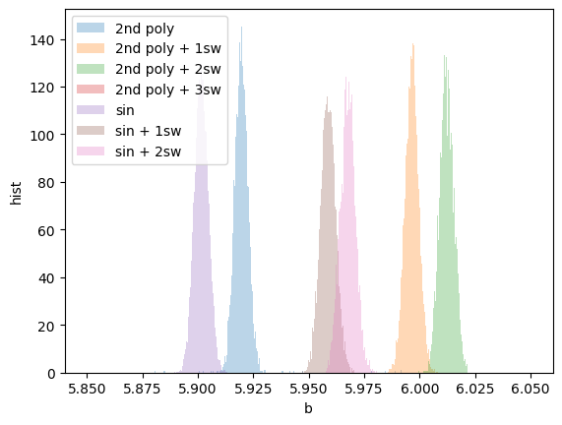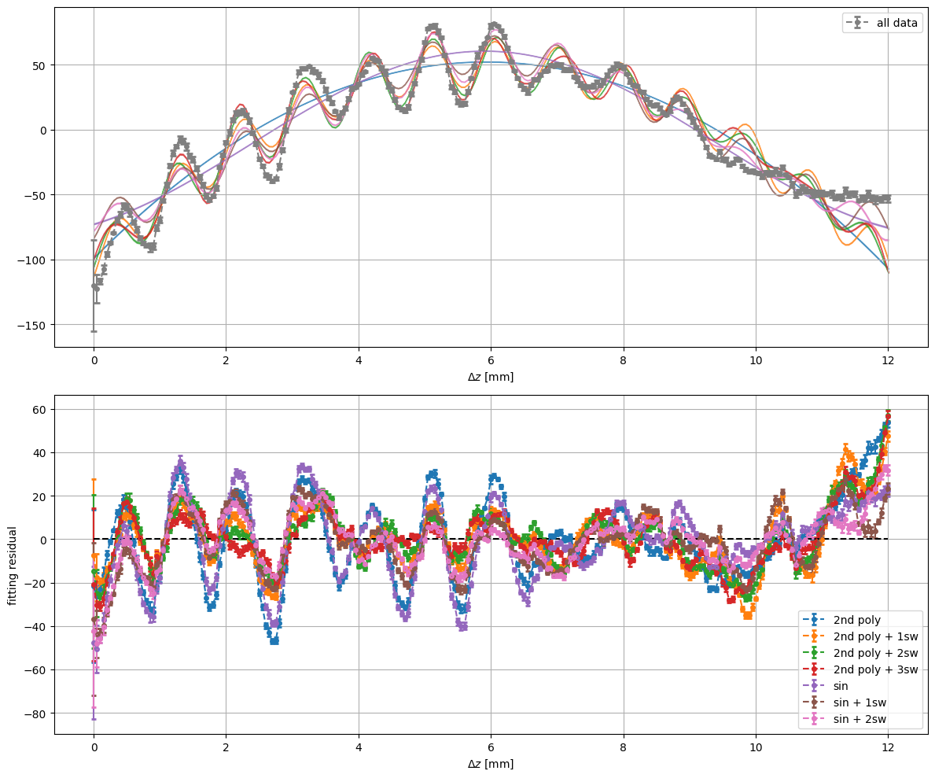

Results at 1.47 m: